**CHAPTER III**

**RESULTS AND DISCUSSION**

This chapter contains the findings and data analysis of the study. The results and discussion are presented as what was stated in the problem.

* **The Existing practices and processes of the school clinic in terms of: Recording patient information**

The Advisers and subject teachers endorse students who are in need of medical assessments and are given first aid treatment and/or referral for further examinations to Regional Hospital Unit (RHU) and Hospitals. Medical records are kept at school clinic and these are kept in folders that are arranged per grade and section, that are place at the clinic’s cabinet.

* **Nutritional status record**

The Nutritional status records are well recorded, because MAPEH teachers are the one taking the records and are submitted to the division office in time and which the nurse or clinic will keep the records of the student.

* **Deworming records**

The deworming records is taken from the number of students given the medicine and those who refuse, which is done by the school nurse.

* **Updating the check-up records of patients**

The school clinic lacks records for updating the check-up records of the patients. Appointments and scheduling of check-up of patients, is only the referred students by their adviser or teacher which are given assessments.

* **Generating patient’s reports**

The reports are generated and consolidated by the nurse on which advisers are required to submit to their respective curriculum chairs.

The medical records are kept as long as the student is enrolled in the school before the deposal of the records.

1. **The problems and challenges encountered the existing practices and processes of the school clinic**

The school only designate nurses who are also teachers that cannot function as full-time school nurses. Records were not organized and the school lack facilities as well.

* **Recording patient information**

Due to the increasing number of students they do not have a system that may keep records and update faster the patient’s medical records.

* **Nutritional status record**

The Nutritional status records are well recorded because MAPEH teachers are the one taking the records and are submitted to the division office in time but, it is hard for them to keep track of the records with the increasing number of students and patients.

* **Deworming records**

The deworming records are recorded manually and kept in an excel file which they use as a clinic report in the school.

* **Updating the check-up records of patients**

The school clinic lacks records for updating the check-up records of the patients. Appointments and scheduling of check-up of patients, is only the referred students by their adviser or teacher which are given assessments.

* **Generating patient’s reports**

The generating of patient’s reports, the records from the adviser/teachers may sometimes be late in submitting reports or none at all.

1. **What system can be developed to support the management of the school clinic?**

The system that can helped support the management of the school clinic is a system that can utilize and organize the files and records of the school clinic.

1. **What is the extent of compliance of the proposed system with ISO 25010:2015 Software Quality Standards as assessed by the user-participants and IT expert-participants in terms of the following?**

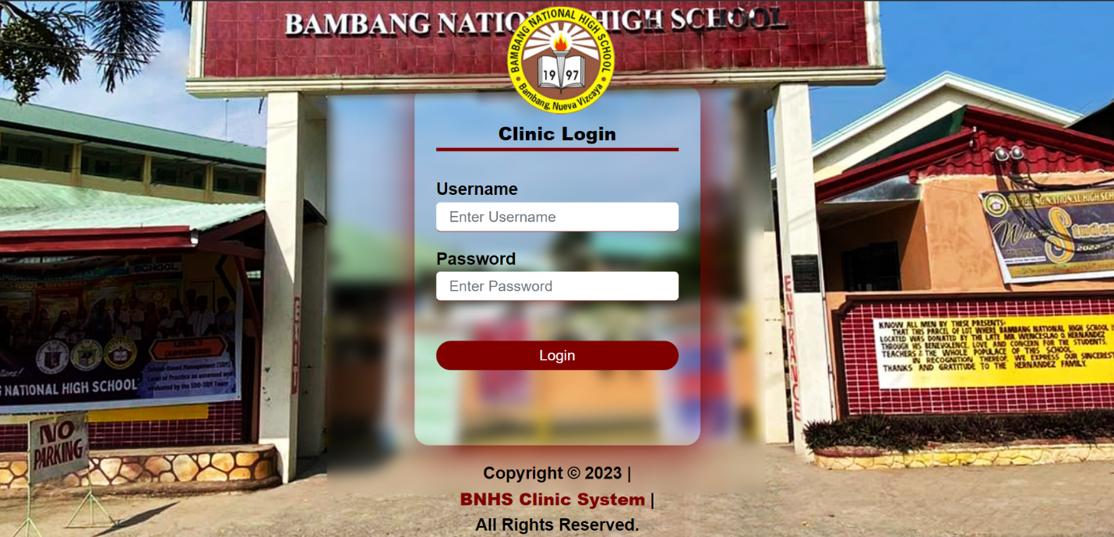**System Development**

* **Main Page / Login page**

*Figure 1.* Login

**Login Page –** On this page, the user can log in to the system.

**Username-** In order to access the system, users can enter their registered username.

**Password-** By doing so, users are able to log onto the system using their registered password.

**Login -** This will enable system login for the user.

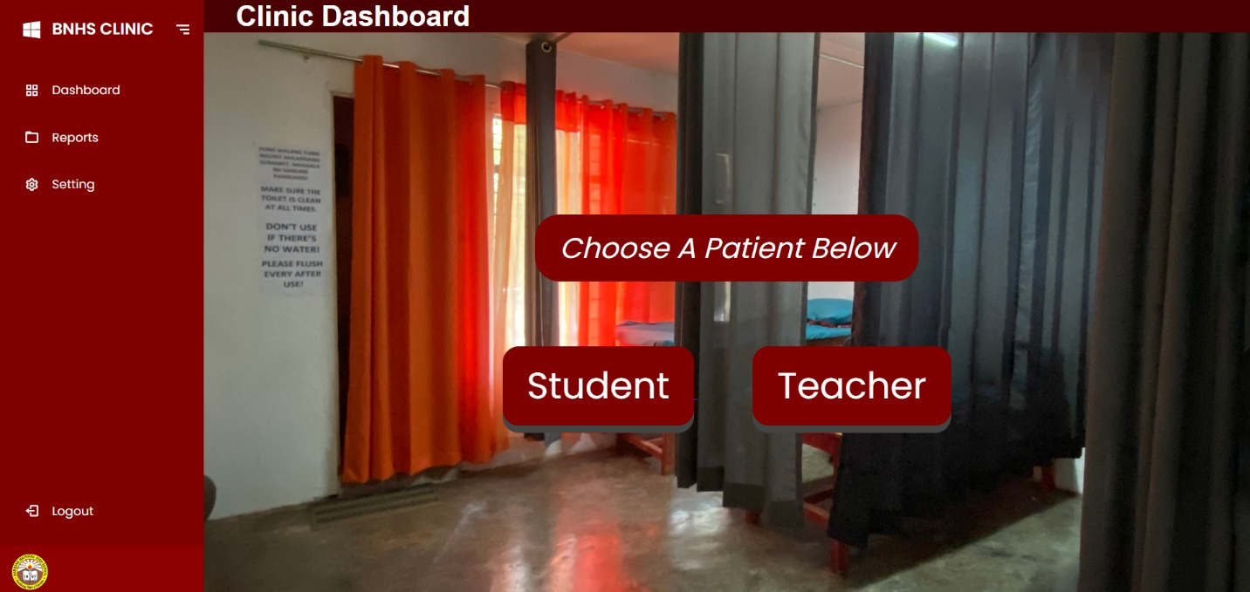

*Figure 1.1.* Main Clinic dashboard

**Dashboard Page**- This page serves as the main dashboard of the clinic where the user can choose the type of patient and generates clinic reports.

**Reports –** This page’s function will show and generate the clinic medical reports.

**Setting –** This page’s function will show the grade and section and even the user’s that have been registered.

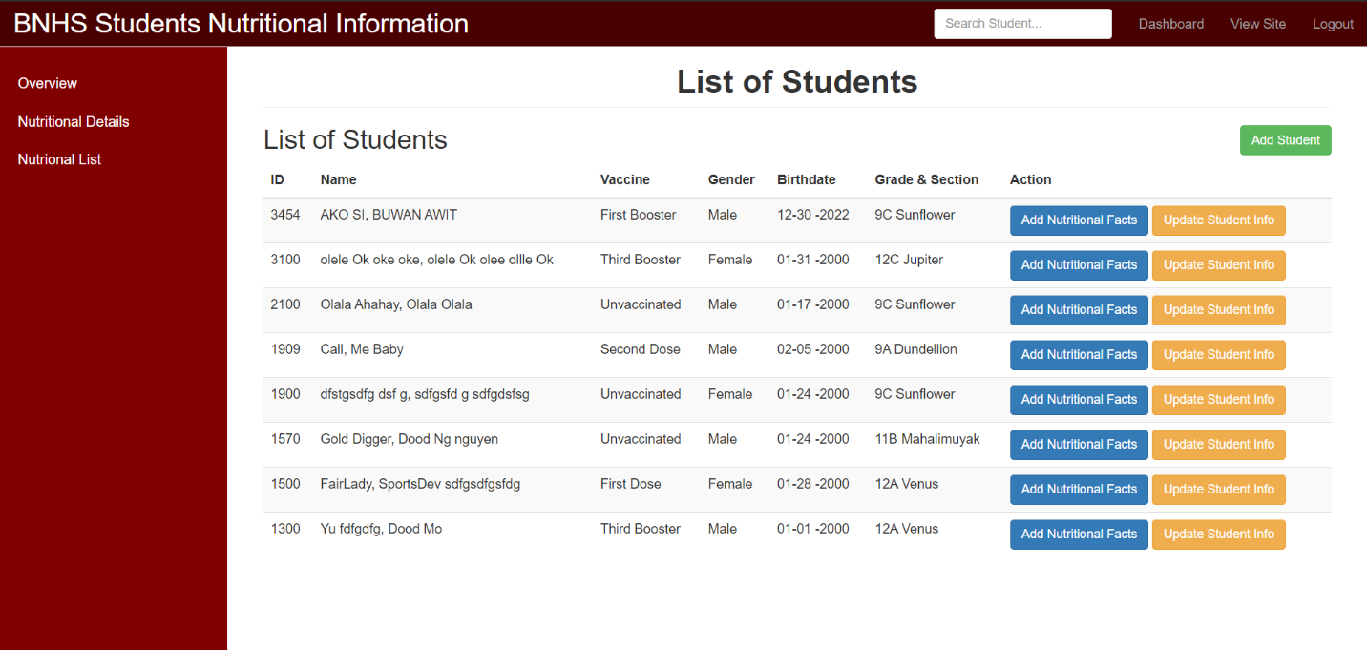**Logout-** This function will return and logout the user to the main page of the system.

*Figure 1.2.* Reports (Nutritional Details

**Overview-** The overview function will return to the main clinic dashboard.

**Nutritional Details-** This function will show the List of student patients where you can add their nutritional status and also update their information.

**Nutritional Lists-** This function will show the List of student patient’s Nutritional status Reports.

**Add Student-** This function let the user add a student patient to the list.

**Add Nutritional Facts-**This function let the user add the nutritional details of the patient.

**Update Student Info-** This function let the user update and edit the student patient’s information.

**Dashboard-** This function servers as the main button to go back to the Nutritional details.

**View Site-** This function servers as the main button to go back to the Clinic main Dashboard.

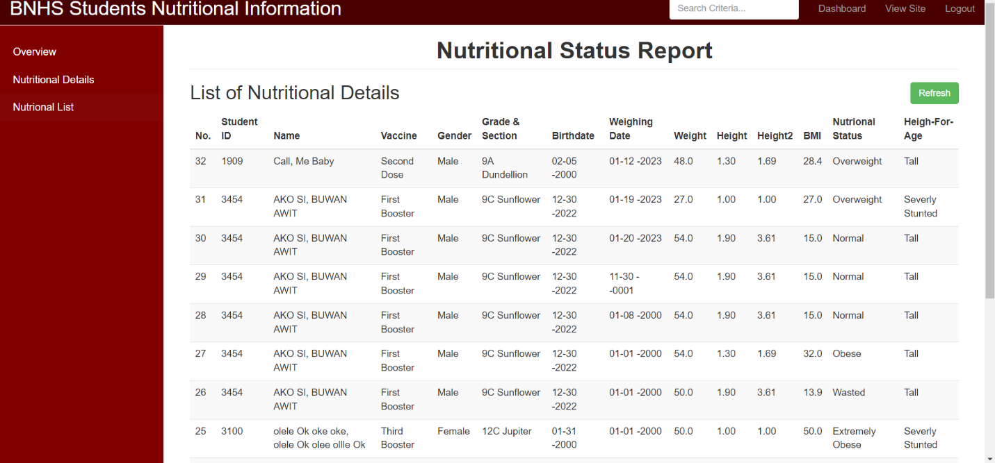**Logout-** This function will terminate the user’s session in the system and return to the login page of the system.

*Figure 1.3.* Nutritional List

**Nutritional Lists-** This function will show the List of student patient’s Nutritional status Reports.

**Refresh**- This function allows the user to reload the report list of patients.

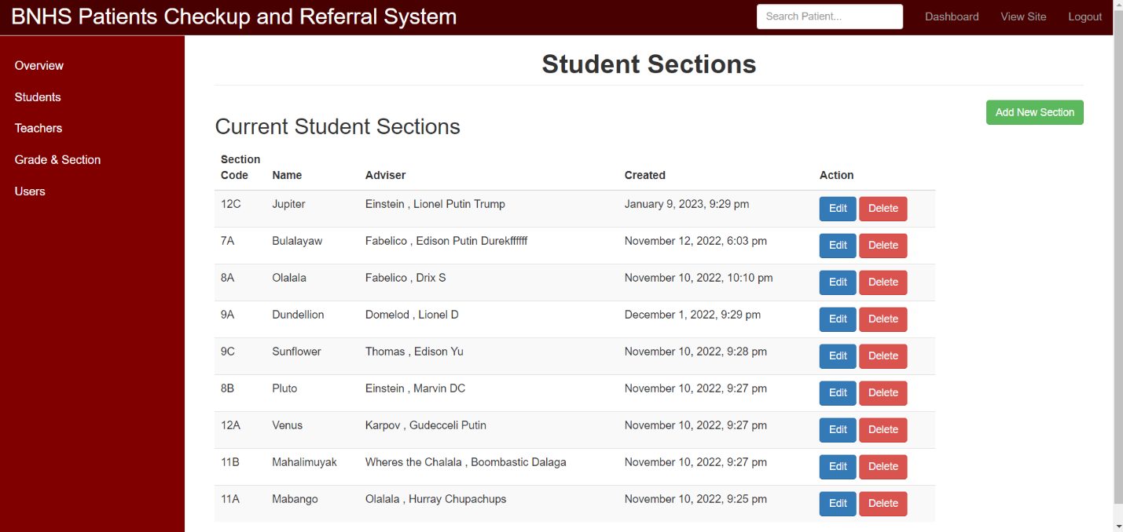

*Figure 1.4.* Settings (Grade and Section)

**Add New Section-** This Function will let the user add new section details.

**Edit-** This Function will let the user edit the section details.

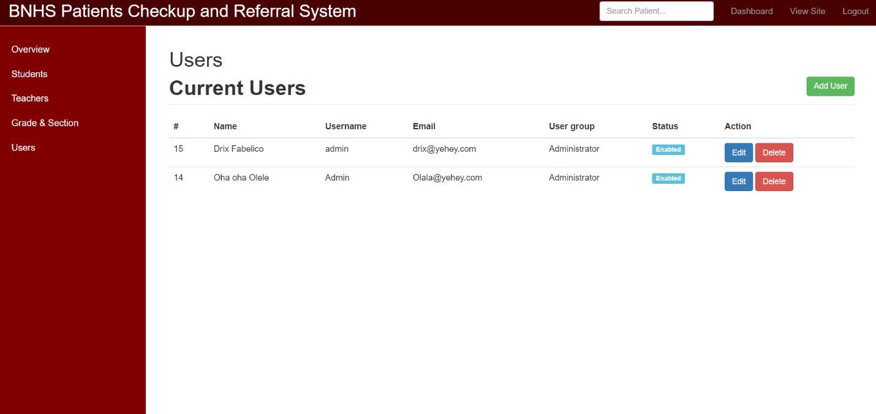**Delete-** This Function will let the user delete the selected section.

*Figure 1.5.* Settings (Users)

**Add User-** This Function will let the user add new authorized user that can access the system.

**Edit-** This Function will let the user edit the user’s details.

**Delete-** This Function will let the user delete the selected user’s details and account.

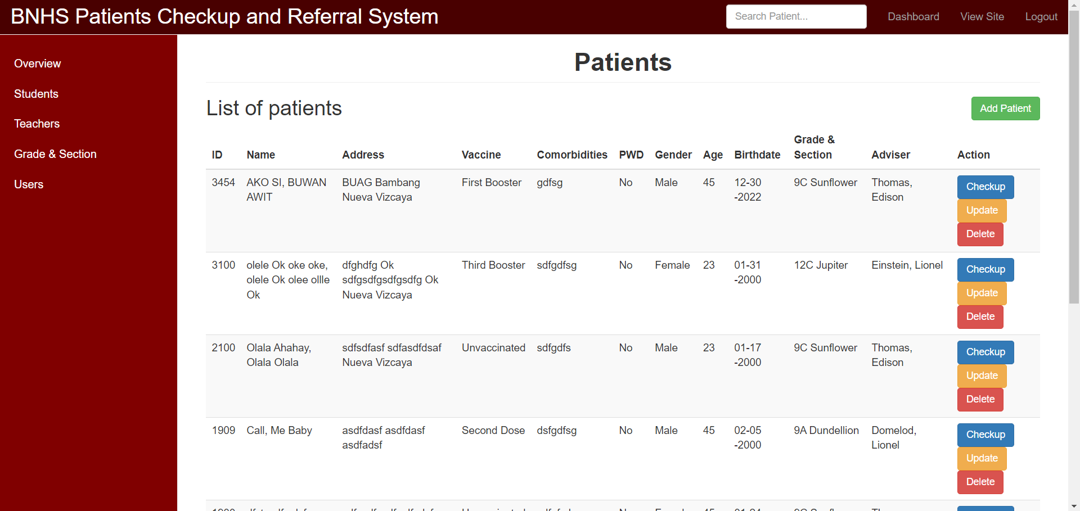

*Figure 1.6.* Student Patient List

**Students-** This function will show the list of student patients in the system.

**Add Patient-** This Function will let the user add a new student patient to the system.

**Checkup-** This function let the user add check-up details to the student patient for their medical history.

**Update -** This Function will let the user update the details and information of the student patient.

**Delete-** This Function will let the user delete the selected patient’s entire details and account.

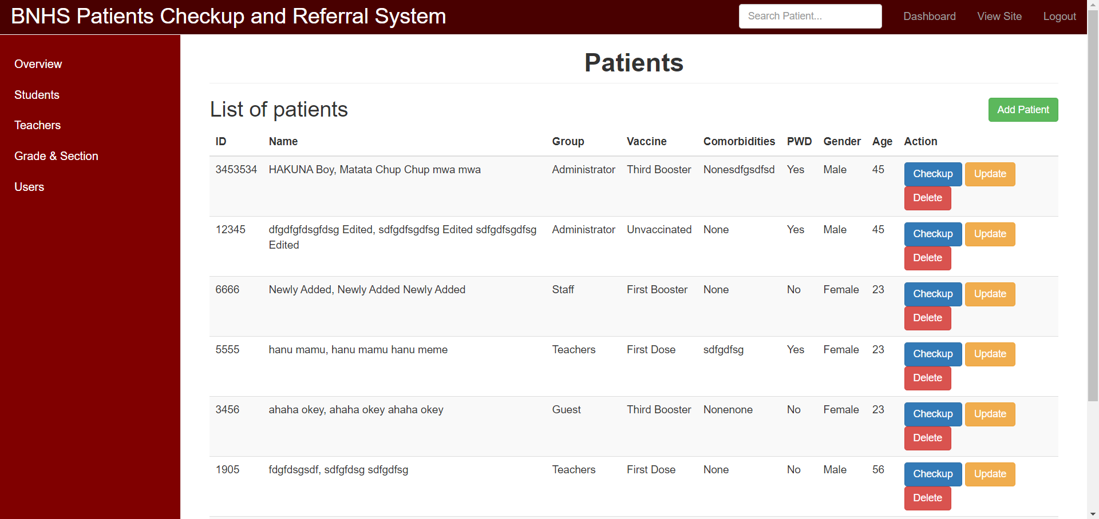

*Figure 1.7.* Teacher Patient List

**Teachers-** This function will show the list of teacher or staff patients in the system.

**Add Patient-** This Function will let the user add a new teacher patient to the system.

**Checkup-** This function let the user add check-up details to the teacher patient for their medical history.

**Update -** This Function will let the user update the details and information of the teacher patient.

**Delete-** This Function will let the user delete the selected patient’s entire details and account.

**CHAPTER IV**

**SUMMARY FINDINGS AND RECOMMENDATIONS**

**Summary Findings**

**Recommendation**

With the conclusion discussed above, the following recommendations are suggested:

1. That the future researchers will integrate the system registration of student profile in the internet.
2. That the future researchers will use this study as a basis to help promote the clinic medical management system to other Dep-Ed schools.